Multiple-choice section

|  |  |  |  |  |  |  |  |  |  |  |
| --- | --- | --- | --- | --- | --- | --- | --- | --- | --- | --- |
| Question | 1 | 2 | 3 | 4 | 5 | 6 | 7 | 8 | 9 | 10 |
| Answer | C | B | D | D | A | A | B | A | C | D |

Question 1 [4.1]

C

|  |  |  |  |  |
| --- | --- | --- | --- | --- |
| Ones | . | Tenths | Hundredths | Thousandths |
| 1 | . |  |  |  |
| 0 | . | 7 | 1 |  |

0.71 =

Question 2 [4.1]

B

Each interval is 0.01. The arrow points to 1.06.

Question 3 [4.2]

D

5.376

Look to the next digit after the second decimal place i.e. 5.38.

Question 4 [4.3]

D

 = 

Question 5 [4.5]

A

2.4 × 3 = 7.2

Question 6 [4.7]

A

 $\frac{2}{5}$ as a percentage:

|  |  |
| --- | --- |
| Method 1: Multiply by 100% | Method 2: Change to a fraction out of 100 |

Question 7 [4.7]

B

0.46 written as a percentage = 0.46 × 100%.  
This moves the decimal point 2 places to the right. So, 0.46 = 46%.

Question 8 [4.8]

A



$=\frac{10}{100}×\$40=\frac{1}{1}×\$4=\$4$

Question 9 [4.8]

C



Question 10 [4.9]

D

There are 3 ducks to 4 bees so ratio is 3 : 4.

Multiple-choice total marks: 10

Short answer section

Question 11 3 marks [4.3, 4.9]

(a) To write a fraction as a decimal you *divide* the numerator by the denominator.

(b) A *recurring* decimal is one that has a repeating pattern of digits.

(c) A *ratio* is a comparison of two or more quantities using a ‘:’ symbol.

Question 12 3 marks [4.1]

(a)

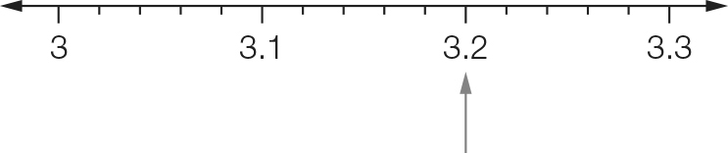

(b)

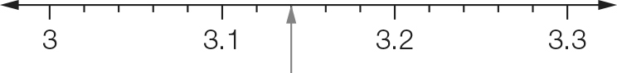

Each interval is 0.02. You need two intervals after 3.1.

(c)

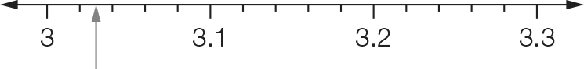

Each interval is 0.20. 3.03 is halfway between 3.02 and 3.04.

Question 13 2 marks [4.1]

(a) $4+\frac{3}{10}+\frac{6}{100} = 4.36$

(b) $\frac{3}{100}+\frac{1}{1000}+\frac{5}{10000}=0.0315$

Question 14 2 marks [4.1]

(a) 3.021, 3.12, 3.21

(b) 0.00574, 0.05074, 0.0574

Question 15 1 mark [4.1]

|  |  |  |  |  |
| --- | --- | --- | --- | --- |
| Ones | . | Tenths | Hundredths | Thousandths |
| 1 | . |  |  |  |
| 2 | . | 0 | 3 | 6 |

2.036

Question 16 3 marks [4.2]

(a) 12.734 ≈ 12.7  
The digit after the 7 is 3. This is less than 5 so the 7 is not rounded up.

(b) 0.3481 ≈ 0.35  
The digit after the 4 is 8. This is more than 5 so the 4 is rounded up.

(c) 1.095 ≈ 1.1  
The digit after the 9 is 5. This is rounded up to 1.10.

Question 17 3 marks [4.2]

(a) 45.657 = 45.66 (2 d.p.)

(b) 1.3758 = 1.376 (3 d.p.)

(c) 34.437 = 34.4 (1 d.p.)

Question 18 2 marks [4.4]

|  |  |
| --- | --- |
| (a) 2.4 + 6.32  8.72 | (b) 6.00  0.70 + 1.25  7.95 |

Question 19 2 marks [4.4]

|  |  |
| --- | --- |
| (a) 1 . 3 6 5 − 0 . 2 3 4  1 . 1 3 1 | (b) ${}_{}^{1}2^{2}3 .^{3}4{}_{}^{1}0 -$ |

Question 20 3 marks [4.5]

(a) 35.78 × 100 = 3578

(b) 0.7634 × 1000 = 763.4 (move 3 decimal places right)

(c) 4.1 × 5 = 20.5

Question 21 2 marks [4.5]

(a) 2.5 × 300   
= 2.5 × 3 × 100

= 7.5 × 100  
= 750

(b) 0.4 × 0.7  
(4 × 7 = 28)  
0.4 × 0.7 = 0.28

(2 decimal places in the question, so there are 2 decimal places in the answer)

Question 22 3 marks [4.6]

(a) 36.63 ÷ 10 = 3.663 (move 1 decimal place left)

(b) 7.09÷ 100 = 0.0709 (move 2 decimal places left)

(c) 23.2 ÷ 4 = 5.8  


Question 23 6 marks [4.7]

|  |  |  |
| --- | --- | --- |
| Fraction (simplest form) | Decimal | Percentage |
|  | 0.1 | 10% |
|  | 0.5 | 50% |
|  | 0.25 | 25% |
|  | 0.2 | 20% |
|  | 0.75 | 75% |
|  | 0.6 | 60% |
|  | 0.333… | 33.33% |

Question 24 2 marks [4.8]

|  |  |
| --- | --- |
| (a) | (b) |

Question 25 2 marks [4.8]

16 marks out of 40:



Question 26 4 marks [4.9]

(a) 3 : 5 (× 4)  
= 12 : 20 (÷ 2)  
= 6 : 10

(b) 1 : 5 : 7 (× 3)  
= 3 : 15 : 21

Short answer total: 43

Extended answer section

Question 27 7 marks [4.1, 4.4, 4.6]

(a) and (b)

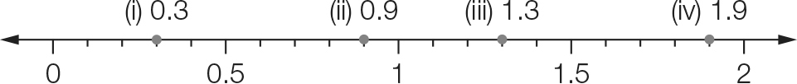

(c) A is at 0.56.

(d) Using the number line:

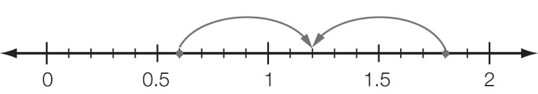  
The point halfway between 0.6 and 1.8 is 1.2.

Using arithmetic:

(0.6 + 1.8) ÷ 2 = 2.4 ÷ 2 = 1.2

Question 28 6 marks [4.4, 4.8, 4.9]

(a) 16.06 – 0.12 = 15.94 seconds

(b) 16.34 – 15.94 = 0.4 seconds

(c) (i)   
One serve is 2040 kJ.

(ii) The breakfast serving size is 2 × 2040 = 4080 kJ.

(d) breakfast : lunch  
= 2 : 2  
= 1 : 1

(e)



Extended answer total: 13

TOTAL test marks: 66